ALISTAIR SPEED MEMORIAL 50
(INCORPORATING CTT SCOTTISH CHAMPIONSHIP AND
SVTTA HARRY ROBERTS)
SUNDAY 26 MAY 2024
8.00 AM START
COURSE WE50.03

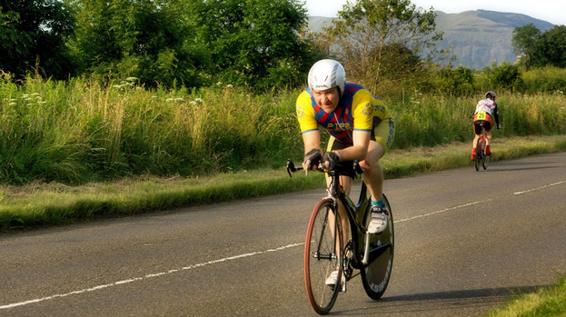

PROMOTED BY FIFE CYCLING ASSOCIATION
ON BEHALF OF CYCLING TIME TRIALS ASSOCIATION
UNDER THEIR RULES & REGULATIONS

Organiser: Mhairi Laffoley, 22 Frankfield Place, Dalgety Bay
Tel: 01383 822349 or email: mhairilaffoley@gmail.com

Alistair was introduced to the sport of cycling from a very young age by his dad, Archie, and he became a member of the Fife Century Road Club at the age of 8. He was to become a very active member and started competing at the age of 12 and continued to compete until his untimely death in September 2013 at the age of 49. He also regularly officiated at events and his time-keeping skills were second to none.

Over the years he travelled the length and breadth of the country, representing the Fife Century, taking part in events ranging from 10 miles to 12 hours, often having come straight from a night shift but he always had a smile and a friendly word for his fellow competitors and for those officiating.

Alistair was always at his happiest when cycling was involved and he was so proud that his nephew, Gavin, had taken up the family sport. They spent many hours together either at events or just going for a run on their bikes right up until the evening prior to his death.

It is hard to believe that it is nearly 11 years since we lost him, but the happy memories live on. I am sure that many of you will also have happy memories of time spent with Ali.

Event Headquarters (open from 7 am)
Freuchie Cricket Club, Muir Road, Freuchie KY15 7HW
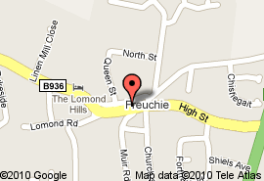
Parking
HQ
Weather permitting parking will be on the perimeter of the cricket club field at HQ, however, if we have had heavy rain prior to the event, we are unable to park on their grounds. If this is the case parking will be available on-street or at car park in the centre of Freuchie, just off Lomond Road. Please do not block driveways, lowered kerbs, etc
PLEASE NOTE THERE WILL BE NO PARKING AT THE EVENT START

Parking
A92

PLEASE NOTE THAT THE START/FINISH OF THE COURSE IS DIFFERENT THIS YEAR TO THAT PREVIOUSLY (due to extremely poor road condition at one section which is deemed too unsafe to race through at the moment)
Parking

Warming Up
Competitors are requested not to warm up on the course after the event has started.

Start
The start is at the layby on the A912 just West of New Inn Roundabout; there is only room for officials to park in the layby. There are 2 ways to get to start; either along the B936 to Falkland and then left onto A912 which is the road the race starts on (approx. 4 miles from HQ); or head south on A92 up Freuchie Brae to New Inn Roundabout where you turn right onto A912 (approx 1 ½ miles from HQ - this is a busier road and the road that the race travels over so riders heading to start this way will have to cross over the race route). If choosing the second option great care and attention is needed when exiting Freuchie onto A92.
No room for parking or warming up at start line layby.

Course
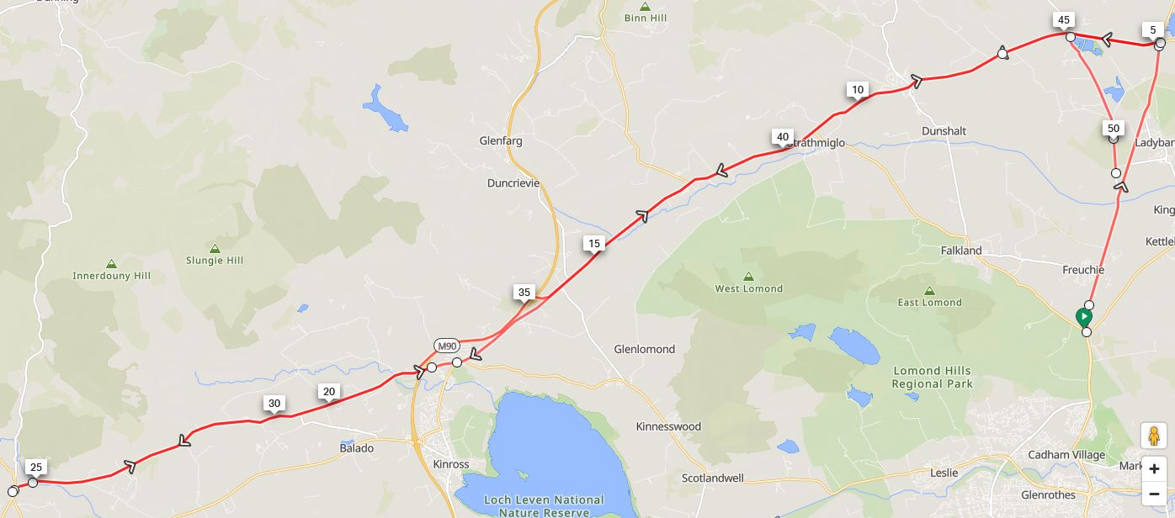
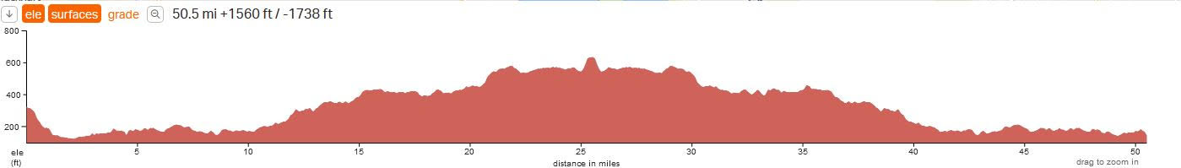
From start proceed East to New Inn Roundabout (approx. 50 yds). Turn left at New Inn Roundabout onto A92 and continue on A92 to Melville Lodges Roundabout (4.8 miles) Turn left onto A91 and proceed through Auchtermuchty, Gateside, Burnside and continue to Milnathort (17.9 miles). Straight over at mini roundabout remaining on A91 out to Yetts O Muckhart (25.5 miles). Turn by taking right hand lane and follow one way section to return the way you came along A91 to Milnathort (33.1 miles). Continue on A91 through Gateside and Auchtermuchty to Melville Lodges roundabout (46 miles). Circumvent roundabout and retrace along A91 for approx. 1 mile. Turn left at Trafalgar Junction onto B937 to finish approx. 10 metres South of Heatherhall Junction.

The course will be well signposted and marshalled.

ATTENTION
Milnathort Roundabout
The roundabout in Milnathort does not have good site lines especially on the return leg. Riders will have to slow down adequately as they will not see if the road is clear to continue until the last minute. Riders not slowing appropriately for the junction and felt to be riding dangerously will be disqualified. There is a large pot hole in the centre of the mini roundabout so it is advisable not to go over the roundabout but to go round it.

20 MPH Speed Zone
The event goes through one short section of 20mph speed restricted road. This is for approx. 150 m in Milnathort High Street (Burleigh Road to Milnathort Mini Roundabout) – riders will be going straight ahead at roundabout and continuing to Yetts o Muckhart where they will turn round the one way system to return to Milnathort where they will retrace over the section of 20 mph restricted road. Riders should be slowing for the roundabout in both directions as the sight lines are very poor. Riders are reminded that the rules of CTT have always required riders to ride safely and OBEY ALL TRAFFIC SIGNS together with the Highway Code and failure to do so is a disciplinary offence and may lead to disqualification

Speed Cushions
Please note there are also Speed Cushions on the course (noted on course Risk Assessment):

On entering Gateside from East there are speed cushions (3 sets) in road.
(These are the type in the middle of each carriageway with room for cyclists to go up either side)

On exiting Gateside from East there are speed cushions (2 sets) in road.
(These are the type in the middle of each carriageway with room for cyclists to go up either side)

These are covered again on the return leg of event.

M90 Motorway
Please note that you take the left hand fork on A91 to Milnathort at the motorway junction. Going straight on will lead you onto the M90 motorway – which hopefully you know is not a very good idea!

Other Things to Note
- New CTT Guidelines – All riders must have a working FRONT & REAR LIGHT fitted to their bikes. ALL riders must wear a helmet. NON-COMPLIANCE WILL MEAN NO START.
- Covid is still doing the rounds so If you are not well or are showing any signs of covid please do not come to the event.
- We will have access to the Cricket Club grounds for parking (please park on the perimeter & not on the pitch)
- When parking please use common sense and do not block any gates.
- Please remember to sign out after finishing and return your number.
- We will have access to changing rooms so please use these for changing. You are asked not to change in full view of any residents. We are incredibly lucky to have this facility, so please do not give them any reason to take it away.

RESULTS/PRIZES
- Prize giving will be undertaken at HQ after the last rider has finished. There will be teas/coffee and light refreshments back at HQ – there will be a donations box for these for charity.

Thanks
Many thanks to all the volunteers helping today without them the race would not be able to go ahead. Thank you also to those of you who have generously donated towards the prize fund today, including the SVTTA.

Prizes

Mens Lady’s Vet’s Lady Vet
^{1st} ^{1st} ^{V40} ^{FV50}
^{2nd} ^{2nd} ^{V50} ^{FV60}
^{3rd} ^{3rd} ^{V60} ^{FV70}
^{4th} ^{V70}
^{V80}

SVVTA Member on Standard SVTTA Team on Standard
1st
2nd

Alistair Speed Spot Prize Road Bike Espoir

One rider one prize apart from SVTTA prizes.

THERE WILL BE NO NUMBER 1 AS THIS HAS BEEN LEFT BLANK IN HONOUR OF ALISTAIR

FCA Open 50
No | NAME | CLUB | CAT | START | FINISH
1 |  |  |  | 8.01
2 | David Kirton | Kennoway RC | V | 8.02
3 | Fred Denton | St Christopher’s CC | V | 8.03
4 | Laura Van Zyl | Fife Century RC | FV | 8.04
5 | Andrew Wilson | St Christopher’s CC | V | 8.05
6 | Lorraine Masterton | Edinburgh RC | FV | 8.06
7 | Stewart Mitchell | Deeside Thistle CC | V | 8.07
8 | Angela Paterson | Musselburgh RCC | FV | 8.08
9 | Tony Cooper | Stirling Bike Club | V | 8.09
10 | Miriam Rennet | Kinross CC | FV | 8.10
11 | James Robb | Deeside Thistle CC | V | 8.11
12 | Sarah Scott | Torvelo Racing | F | 8.12
13 | Liz Ball | Valley Striders CC | FV | 8.13
14 | Ross Allan | St Christopher’s CC | V | 8.14
15 | Robert Holmes | Kinross CC | V | 8.15
16 | Kevin Duffy | Glenmarnock Wheelers | V | 8.16
17 | Martin Gordon | Coatbridge Clarion CC | V | 8.17
18 | Steve Wallace | Dunfermline CC | V | 8.18
19 | John Walker | Lomond Roads CC | V | 8.19
20 | Liam McNamara | Elgin CC | Sen | 8.20
21 | William Bunyan | Team Andrew Allan Architecture | V | 8.21
22 | Oscar Marletta | VC Glasgow South | V | 8.22
23 | Steven Purdie | Glasgow Green CC | V | 8.23
24 | Tracy Wilkinson-Begg | Vanelli Project GO | FV | 8.24
25 | Lewis Keoghan | Royal Albert CC | Espoir | 8.25
26 | Scott Hutchinson | Dunfermline CC | V | 8.26
27 | Thomas Brown | Johnstone Wheelers | Sen | 8.27
28 | Alastair Pell | Glasgow Nightingale | V | 8.28
29 | Stephen Beecher | West Lothian Clarion | V | 8.29
30 | Findlay Watt | Dunfermline CC | V | 8.30
31 | Alan Macintyre | Coatbridge Clarion CC | V | 8.31
32 | Kevin Belton | Forress CC | V | 8.32
33 | Robert Marshall | Team Andrew Allan Architecture | V | 8.33
34 | Alexandra Hayden | Vanelli Project GO | F | 8.34
35 | Graham Jones | Edinburgh RC | V | 8.35
36 | Randle Shenton | Border City Wheelers | V | 8.36
37 | Patricia Baird | Ecosse Performance CC | FV | 8.37
38 | John Macarthur | Glasgow Nightingale CC | Sen | 8.38
39 | Jon Fairclough | Kelso Wheelers CC | V | 8.39
40 | James Muir | Glasgow Nightingale CC | V | 8.40
41 | Mike Giles | Ythan CC | V | 8.41
42 | Michal Sroka | West Lothian Clarion | V | 8.42
43 | Richard Dowling | Perth United CC | V | 8.43
44 | Craig Patterson | Army Cycling | V | 8.44
45 | Ian Sim | GTR Return to Life p/bStreamline | V | 8.45
46 | Nikki Elder | Hawick CC | V | 8.46
47 | Alan Davidson | Dundee Thistle CC | V | 8.47
48 |  |  |  | 8.48
49 | Joe Hands | GTR Return to Life p/bStreamline | V | 8.49
50 | Sean Quinn | Law Wheelers | V | 8.50
51 | Andrew Scott | Musselburgh RCC | V | 8.51
52 | Andrew Gallacher | Vanelli Project GO | V | 8.52
53 | Leon Marshall | Royal Navy & Royal Marines CA | V | 8.53
54 | Nico Anelli | Real Guts Racing | Sen | 8.54
55 | Rob Graham | GTR Return to Life p/bStreamline | Sen | 8.55
56 | Stephen Wilkinson | Vanelli Project GO | V | 8.56
57 | Stewart Burke | Team Andrew Allan Architecture | V | 8.57
58 | Richard Sanderson | Kinross CC | Sen | 8.58
59 | Marc Anderson | GTR Return to Life p/bStreamline | V | 8.59
60 | Andrew Bruce | Vanelli Project GO | V | 9.00
61 | Angus Wilson | Dundee Thistle | V | 9.01
62 | Ray Wilson | GTR Return to Life p/bStreamline | V | 9.02
63 |  |  |  | 9.03
64 | Douglas Watson | GTR Return to Life p/bStreamline | V | 9.04
65 |  |  |  | 9.05
66 | John Archibald | HUUB WattShop | Sen | 9.06
67 |  |  |  | 9.07
68 | Chris Smart | GTR Return to Life p/bStreamline | V | 9.08

